Low Level Design

Amazon sales review

Version 1.0

Ranjit Kundu

**DOCUMENT CONTROL**

**Change Record:**

**Contents**

**1. Introduction**

**1.1 What is Low-Level Design Document?**

**1.2 Scope**

**2. Architecture**

**3. Architecture Description**

**3.1 Data Description**

**3.2 Data Transformation**

**3.3 Data insertion into database**

**3.4 Export Data from database**

**4. Unit test cases**

**1. Introduction**

**1.1 What is Low-Level design document?**

The goal of the LDD or Low-level design document (LLDD) is to give the internal logic design of the actual program code for the House Price Prediction dashboard. LDD describes the class diagrams with the methods and relations between classes and programs specs. It describes the modules so that the programmer can directly code the program from the document.

**1.2 Scope**

Low-level design (LLD) is a component-level design process that follows a step-by-step refinement process. The process can be used for designing data structures, required software architecture, source code and ultimately, performance algorithms. Overall, the data organization may be defined during requirement analysis and then refined during data design work.

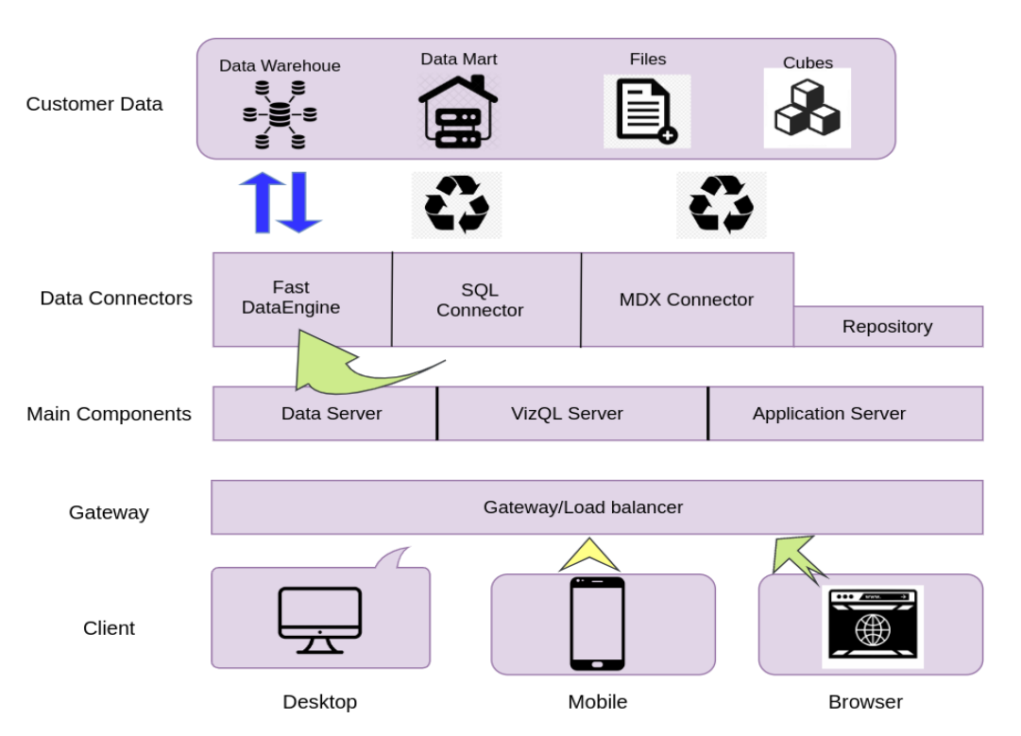**2. Architecture**

**Gateway/Load Balancer: -**

It acts as an Entry gate to the MySQL Server and also balances the load to the Server if multiple Processes are configured.

**Repository: -**

Tableau Server Repository is a PostgreSQL database that stores server data. This data includes information about Tableau Server users, groups and group assignments, permissions, projects, data sources, and extract metadata and refresh information.

**Data Engine: -**

It Stores data extracts and answers queries.

**3. Architecture Description**

**3.1 Data Description**

The Dataset contains Amazon sales data from 2017 – 2019 here some columns described below,

1. Sales price per piece without discount per piece is List Price

2. Total sales price without discount is Sales Amount Based on List Price(List Price * Sales Quantity)

3. Sales price per piece is Sales Price

4. Total sales price is Sales Amount(Sales Price * Sales Quantity)

5. Total discount is Discount Amount(Sales Amount Based on List Price - Sales Amount)

6. Total cost of company during selling a product is Sales Cost Amount

7. Total profit on a product sale is Sales Margin Amount

**3.2 Data Transformation**

In the Transformation Process, we will convert our original datasets with other necessary attributes format.

**3.3 Data Insertion into Database**

a. Database Creation and connection - Create a database with name amazon_sales_data. If the database is already created, open the connection to the database.

b. Table creation in the database.

c. Insertion of files in the table

**3.4 Export Data from Database**

Data Export from Database - The data in a stored database is exported as a CSV file to be used for Data Pre-processing.

**4. Unit test cases**

|  |  |
| --- | --- |
| **TEST CASE DESCRIPTION** | **EXPECTED RESULTS** |
| Generate sales trend chart Yearly, Monthly, Combined and other charts | Default – word cloud chart of products  Monthly – Monthly sales trend report  Yearly – Yearly sales trend report  Yearly Month wise – Month wise yearly sales trend report  Monthly year wise – Monthly year wise sales trend report  Top products – Top 5 products based on sales price and quantity |
| Select the column to generate Data distribution count plot | Distribution plots of amounts like sales amount or discount or others |
| Comparison of sales amounts yearly month wise | Compare two amounts with respect to year and month |